The screen the user is initially greeted with. They are able to select a level and a difficulty from here. They are also given a set of rules that apply when playing, and access to seeing all the top scores for each combination of levels and difficulties.
CI328 – Internet Game Design – Assignment One Report
Game Summary
Objectives
The main objective of the game is to get the highest score possible, which is achieved by getting the ball to bounce the highest number of times. The score can also be modified by bouncing on certain balls that increase your score by a fixed amount.

Rules
- You get three balls you can fire
- If the ball hits the bottom of the screen, that ball is removed from the game
- You can place the ball anywhere during play when you have leftover “teleports”

Gameplay
The user selected first a level and a difficulty, then they are taken to a playing screen when play is pressed. A level is generated (with amount of positive and negative pegs effected by the difficult the user chose) and the user is given control over the angle of the cannon. Once the user presses fire, the ball is shot out and points start accumulating depending on the collisions. When a special “placer” ball is hit, the user is given a “teleport”. These can be accumulated over the game, and to use, the user just presses anywhere on the screen for the ball to appear there.

Game structure
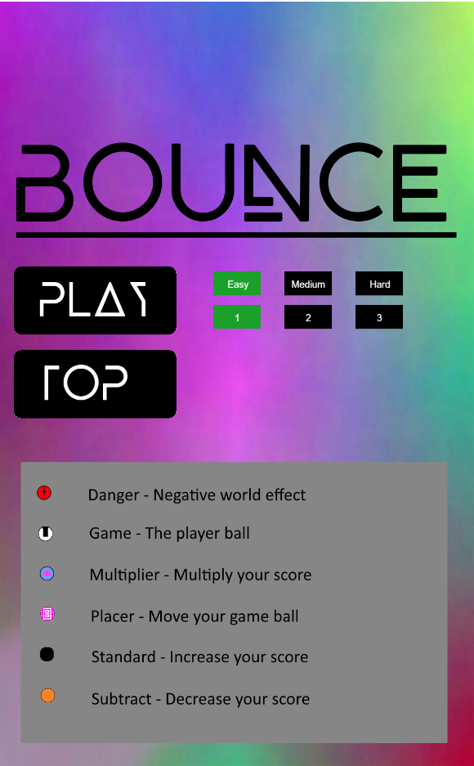

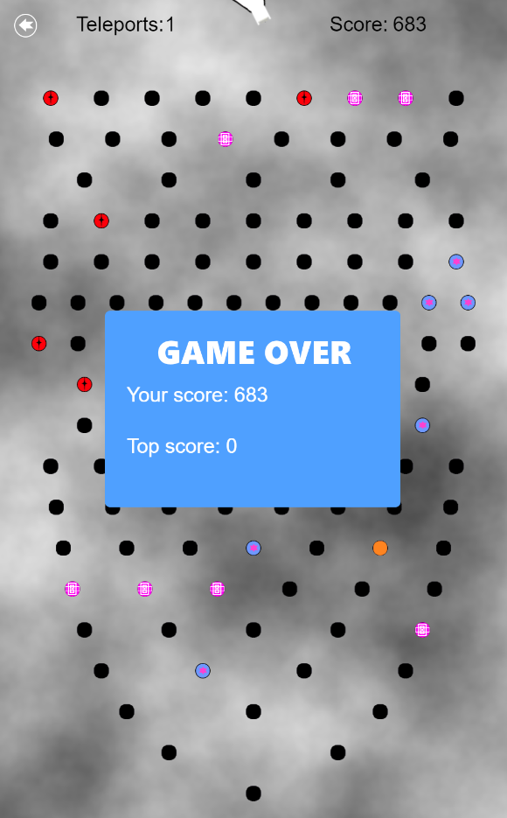
The game in a playing state. The ball has been fired from a user tap, and the game is in progress. The number of available “places” and score are displayed at the top.
The game in a game over state. The score the user achieved, and the current top score for that level is displayed.
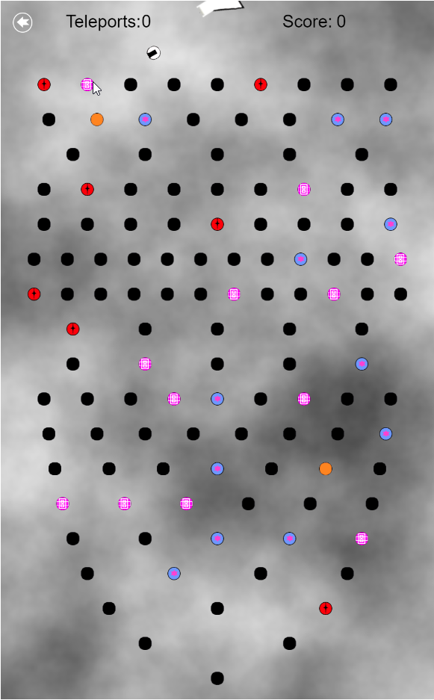

From the menu, pressing on top displays all the high scores from each level combination.
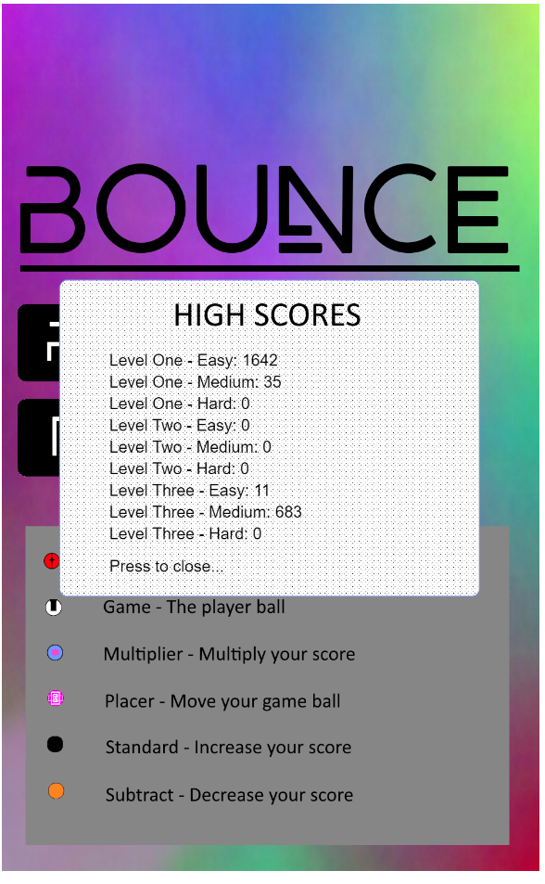

Implementation

main.js
Overview
The last file loaded from the html file is main.js, which is where the game is created. The scale, size and game states are created and set here.

Functions
preload():
0 Parameters
-
Set the scale and size of the game. Also create the states the game can be in. Once completed, call the “init” state.

The States

init.js
Overview
The init state is started after the creation of the game is finished, from main.js. This adds all of the images, sounds and physics .json files to the game cache.

Functions
preload():
0 Parameters
-
Add in all of the assets that will be used later on in the game.

create():
0 Parameters
-
Call the menu state to start.

menu.js
Overview
This state is called from init. This is where all the functionality of the menu screen is.

init():
0 Parameters
-
Add some properties to this state such as the level and difficulty, and also add a property to the button prototype that displays if it has been selected. Once finished, call the checkScoresExist function.

create()
0 Parameters
-
Add the game background, and call the addButtons function to create the buttons.

addButtons():
0 Parameters
-
Add the level and difficulty buttons, along with their text and colours.

checkScoresExist():
0 Parameters
-
Check the local storage of the browser for any saved scores. If a level and difficulty combination does not have a saved score, create one with 0.

removeLevelSelections() / removeDifficultySelections():
0 Parameters
-
Remove the current selected level / difficulty.

levelButtonClick(button) / difficultyButtonClick(button):
button: The pressed button
-
Triggered on level / difficulty button press, change the selected level / difficulty.

playButtonClick():
0 Parameters
-
Change the state to be playing.

scoreButtonClick():
0 Parameters
-
Add the scores sprite, and fetch and display the current high score for each level. Selecting this sprite again will destroy it.

playing.js
Overview
This state is called from menu. This is where all the functionality of the game while it is being played it.

init():
0 Parameters
-
Add properties that are relevant to the game being played, such as the remaining balls, remaining teleports and if there is an active ball. Also initialise the physics system.

create():
0 Parameters
-
Create all of the controllers that handle the majority of the interactions during play. Also call these controllers creation functions that generate the level and balls.

update():
0 Parameters
-
The main update loop for the game. This function determines that rotation of the cannon, and adds listener functions to a tap event. These functions can fire the ball from the cannon, and also teleport the ball if the right circumstances are met. Also adds game over functionality, and will display the current score and the top score when there are no balls left to fire.

determineCannonRotation():
0 Parameters
-
Sets the cannon rotation based on the current position of the pointer.

getLevelAndDifficultyScore():
0 Parameters
-
Return the correct key to use for the score controller to find the current top score in the local storage.

initialisePhysics():
0 Parameters
-
Start the physics system, and set P2 variables such as the gravity and restitution.

Separate Items
gameball.js
Overview
The main ball the user fires, which uses the Phaser.Sprite prototype. When this is created, properties such as thrust and rotation of the body is calculated.

place():
0 Parameters
-
When called, this function places the ball at the position of the active pointer in the game. It changed the recent teleport field for half a second to prevent instant, multiple teleports.

levels.js
Overview
The level data is kept here, with a function to retrieve it

getLevelLayout(number):
number – The level number
-
Call the function to return the required level data, depending on the passed in parameter.

LevelOne() / levelTwo() / levelThree()
0 Parameters
-
Return the level data for each of the levels.

Controllers
collisioncontroller.js
Overview
This controller creates all the collision groups, adds balls to their correct group and handles all collision events between these groups.

createCollisionGroups():
0 Parameters
-
Create all the collision groups that will be used in the game.

addToCollisionGroup(ball):
ball – The ball that needs to be added to a group
-
Depending on the ball type, add the ball to the appropriate collision group.

replaceBall(ball):
ball – The ball that has just been hit
-
Called after a collision, replace the current ball with a new ball (using the ball factory).

standardCollision(gameBall, hitBall):
gameBall – The user ball
hitBall – The ball that has been hit
-
Called after a collision on a standard ball. Plays the standard collision sound, adds to the score and replaces the hit ball.

subtractCollision(gameBall, hitBall):
gameBall – The user ball
hitBall – The ball that has been hit
-
Called after a collision on a subtract ball. Plays the subtract collision sound, take away from the score and replaces the hit ball.

dangerCollision(gameBall, hitBall):
gameBall – The user ball
hitBall – The ball that has been hit
-
Called after a collision on a danger ball. Plays the danger collision sound, increase the gravity and replaces the hit ball.

multiplierCollision(gameBall, hitBall):
gameBall – The user ball
hitBall – The ball that has been hit
-
Called after a collision on a multiplier ball. Plays the multiplier collision sound, increase the score and replaces the hit ball.

placerCollision(gameBall, hitBall):
gameBall – The user ball
hitBall – The ball that has been hit
-
Called after a collision on a placer ball. Plays the placer collision sound, add a teleport point and replaces the hit ball.

levelcontroller.js
Overview
This controller creates all the static sprites, creates all the balls and handles the creation and deletion of the game ball.

createLevel():
0 Parameters
-
Call the creation functions that generate the level and add all the buttons.

ballKilled():
0 Parameters
-
Called on the onKilled event of the gameball. Reset the game gravity and set the activeBall field to false.

addButtons():
0 Parameters
-
Add the return button.

addStaticSprites():
0 Parameters
-
Add the background and cannon sprite to the game.

generateLevel():
0 Parameters
-
Get the desires level layout, and generate each ball in the ball that can be hit. Also call the collision controller to add them to the correct groups.

scorecontroller.js
Overview
This controller handles all interaction with the scores in the game.

createScore():
0 Parameters
-
Creates the initial score parameter for the current game, and adds levels displaying the current score.

createTeleportCount():
0 Parameters
-
Add a teleport sprite and text to the game.

addToScore():
0 Parameters
-
Add one to the current game score.

decreaseScore():
0 Parameters
-
Divide the score by a random number between 1 and 2.

multiplyScore():
0 Parameters
-
Multiply the score by a random number between 1 and 2.

updateScoreText():
0 Parameters
-
Called to update the displayed score text.

updateScoreText(teleportCount):
teleportCount – the number of teleports.
-
Called to update the number of remaining teleports.

getLevelScore():
0 Parameters
-
Return the saved score for the current level and difficulty.

updateLevelScore(levelAndDifficultyIdentifier):
levelAndDifficultyIdentifier – the identifier for the level and difficulty.
-
Set a new scared high score for the current level and difficulty.

